**LAB 08**

Task 01:

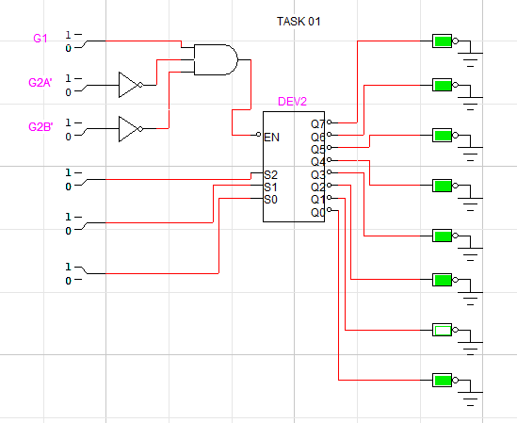

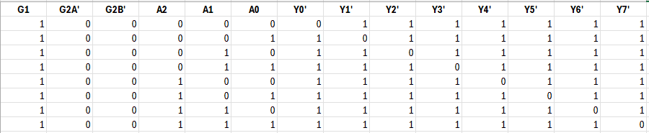

Task 02:

Task 03

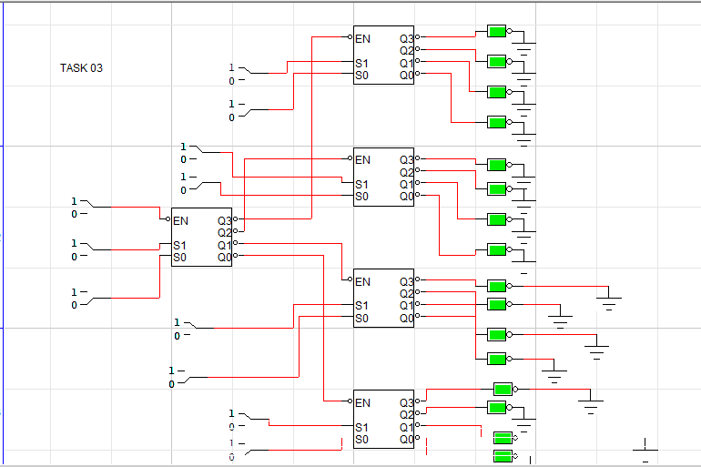

|  |  |  |  |  |
| --- | --- | --- | --- | --- |
| **A3** | **A2** | **A1** | **A0** | **Output (Y0 to Y15) Only one is HIGH** |
| 0 | 0 | 0 | 0 | Y0 = 1, others = 0 |
| 0 | 0 | 0 | 1 | Y1 = 1, others = 0 |
| 0 | 0 | 1 | 0 | Y2 = 1, others = 0 |
| 0 | 0 | 1 | 1 | Y3 = 1, others = 0 |
| 0 | 1 | 0 | 0 | Y4 = 1, others = 0 |
| 0 | 1 | 0 | 1 | Y5 = 1, others = 0 |
| 0 | 1 | 1 | 0 | Y6 = 1, others = 0 |
| 0 | 1 | 1 | 1 | Y7 = 1, others = 0 |
| 1 | 0 | 0 | 0 | Y8 = 1, others = 0 |
| 1 | 0 | 0 | 1 | Y9 = 1, others = 0 |
| 1 | 0 | 1 | 0 | Y10 = 1, others = 0 |
| 1 | 0 | 1 | 1 | Y11 = 1, others = 0 |
| 1 | 1 | 0 | 0 | Y12 = 1, others = 0 |
| 1 | 1 | 0 | 1 | Y13 = 1, others = 0 |
| 1 | 1 | 1 | 0 | Y14 = 1, others = 0 |
| 1 | 1 | 1 | 1 | Y15 = 1, others = 0 |